# Inception Document

# ----System Monitoring Management

## Overview (vision and business control)

How does a user know the performance of his computer’s system? How many percentage of CPU usage do the current applications use? How much space is left of the computer’s memory? In order to realize these functions and help users to monitor their computers’ system immediately and easily, our team will develop an APP which can be downloaded to mobile phones. Therefore, users can monitor computers’ system performance without time and place limit.

## Functions Analysis --- Use-Case model

* Main use-case. This main use-case contains users and administrator(s). It shows a link between user and the administrator to system monitoring management system. There are different functions to the user and administrator.

**Char 1**

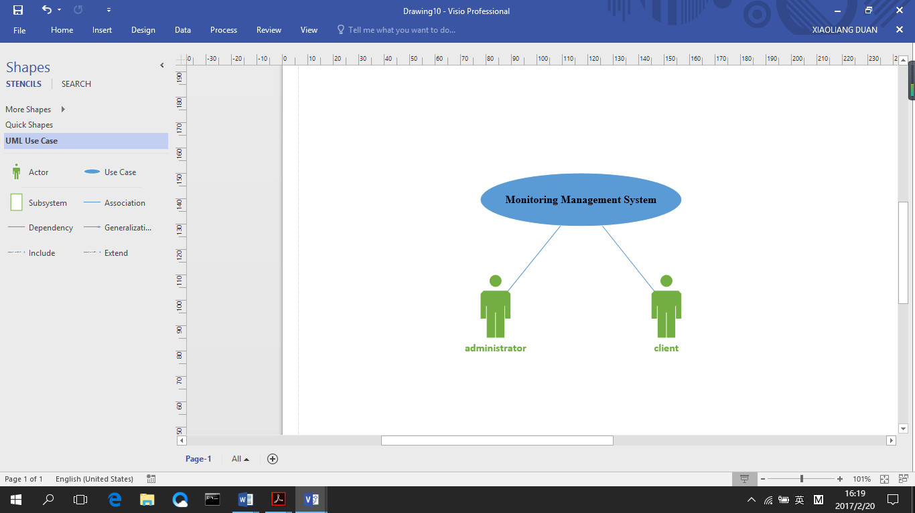

* Client sub-system. This sub-system is the user’s operations which is a user sided view. This diagram shows that the user has to register into the system monitoring management system firstly. The client can view all the detail of this system and check the information about his system. He can update his profile when login the system. He can also check the alarm information that the system had sent to him. In addition, he can view CPU usage, memory usage and storage usage easily in this system.

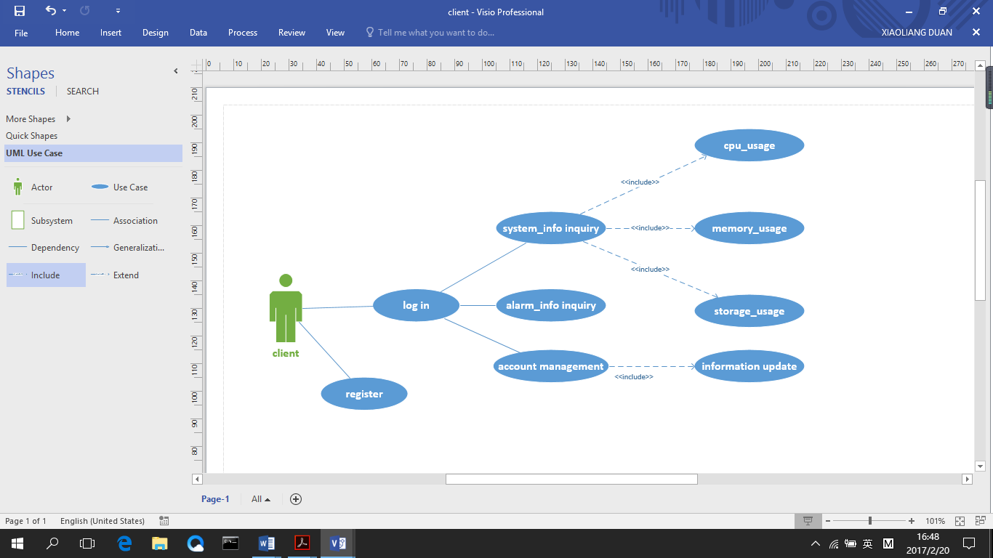**Char 2**

* Administrator sub-system. The diagram below shows all features, categories and defining administrator side view. At first, the administrator must have valid ID to log in and after that he or she can manage clients’ information (add, deletion, edit and inquiry). Moreover, the administrator can manage the system information from the background. He can configure cluster, IP address, account and port and at the same time, he can check system usage of the clients. In addition, the administrator can also review and manage alarm information

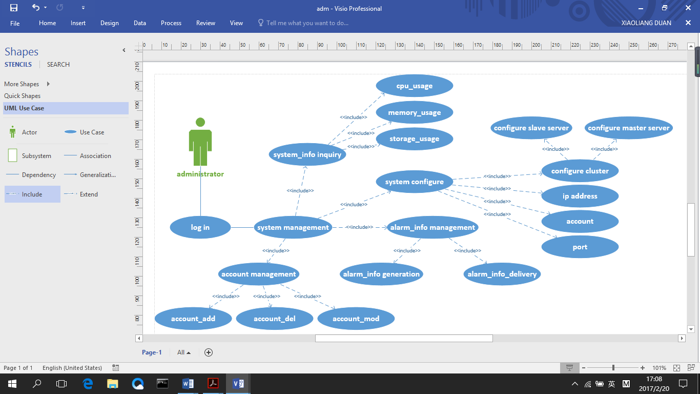**Char 3**

## Supplementary specification

(Key and mostly non-functional requirements with impact on the architecture)

## Glossary

(Domain terminology and data dictionary)

|  |  |  |  |
| --- | --- | --- | --- |
| Glossary | Explain | Glossary | Explain |
| cluster | a grouping of a number of similar computers. | Http | Hyper Text Transport Protocol. HTTP is the foundation of data communication for the World Wide Web |
| master | Principal server, which monitoring other servers. | UDP | User Datagram Protocol. |
| Unix server | A computer, which base on UNIX that provides client stations with access to files and printers as shared resources to a computer network | listening port | Programmers sending data to a particular port cannot expect another program to pick that data. For example, there is no point sending data to port 21, which is registered for the File Transfer protocol, hoping that Kerberos will pick it up, because Kerberos is listening on port 88. |
| Workload | One server need to deal with the whole work | Shell | is a command-line interpreter that reads user input and executes commands. |
| Usage | One server/ equipment has been used |  |  |
| process control | Process control is a statistics and engineering discipline that deals with architectures, mechanisms and algorithms for maintaining the output of a specific process within a desired range. | listening port |  |
| socket | is an endpoint of an inter-process communication flow across a computer network. |  |  |

## Risk List and Management Plan

Describe risks (business, technical, resource, schedule)

1. This is the first project of the team; we didn’t try do the work together. We don’t know each other enough so that we have to exchange information. Some of members have part-time job, and they have to finish the project when they have free time.
2. The project has other similar applications; we have to build a new one so that ours App has unique value. But it is very difficult, we need to think more and do more. We found we can use UNIX and Internet create a App to watch MASTER and SLAVE and exchange data.
3. Data transition can be fast via UDP but it will be very slow via HTTP, we can improve our algorithm, language or size, but we cannot change HTTP transition. We will try to improve the App reduce the bad influence from HTTP.
4. When we design the App, we tried to use two ways. Using html or using application. We discussed that and we cannot find which one is the best for the project.
5. Monitoring Management has an easy UI in Android, we will review a lot of information, we have to let user easy to use. We tried 3 UIs just like squared paper or menu, we will decide one when we finish shell part.
6. **Prototypes and proof of concepts**

Clarify vision, validate technical ideas

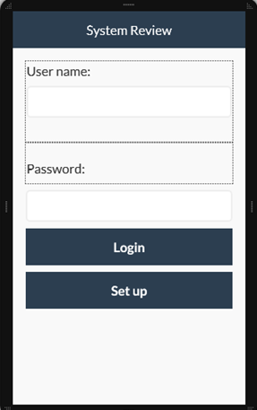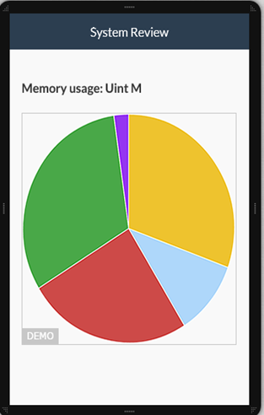

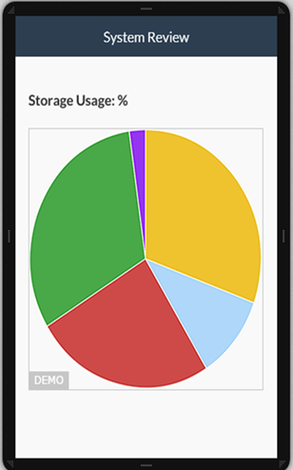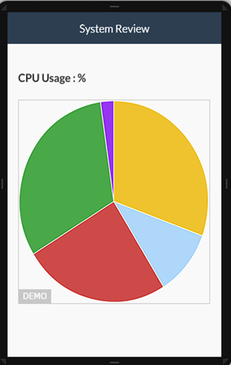

## Iteration Plan

What to do in the first elaboration

## Phase plan and software development plan

In phase 1, we have finished the preliminary design and figured out the main functions of this system. In next phase, we are going to focus on developing this software including elementary implementation of some certain functions and some UI design. The languages we are going to use are C, JavaScript and HTML and the development tool will be Visual Studio. Moreover, the database management tool is MySQL.

In addition, our group has cleared our respective tasks. All our team members giving their best shot, anyone stuck in any phase we work out together to get it done, some of us had experience of designing software before, but some of us have no much experience of how to design. Therefore, our team members plan to do the familiar part individually and unfamiliar parts together. We will have meetings regularly to make sure everyone understand his (her) task, and improve our abilities together.

(Tools, people, education, and other resources)

## Development Case

Customization of UP steps and artifacts for the project